Main Company Heading or Slogan

Ready for growth? owned by you, driven by us.

Your home for digital marketing solutions



What do we do? Innovations and Impact | Left Section

Implementing and managing innovative web marketing techniques to boost your business's profile

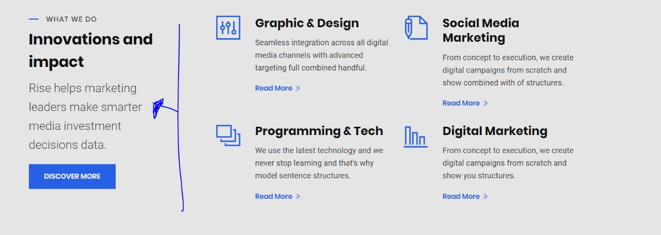

What We Stand For:

Our designers and developers do everything to get the attention of your audience.

**Quality Products:** Our creative experts provide top-notch quality products to make our clients stand out among the rest.

**True Value:** We are true to our goals of providing the best design to increase a brand’s awareness and value.

**Discovering and Sharing:** Our creativity is expanded as we discover and share products.

**Build Faster:** To unlock the gates to bigger opportunities, we build faster, smoother, and more human-touched websites.

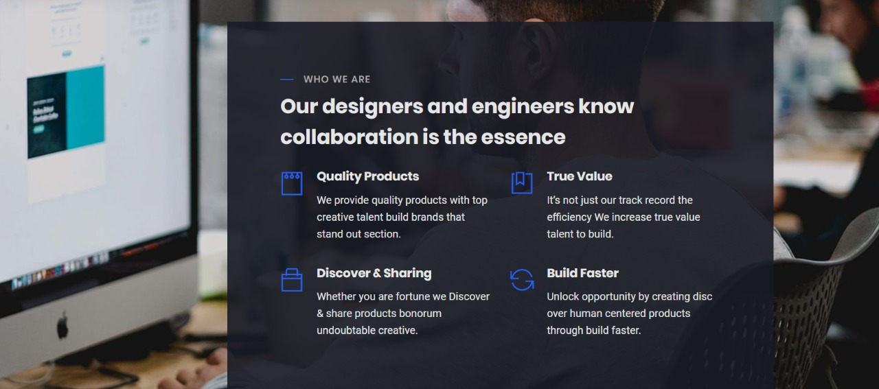

About Us

Let's take action on your challenges real quick.

Schedule your meeting right away.

Are you ready for a meaningful change? Together, let's create this thing!

We create powerful content strategies for corporate brands using our proven and tested "ROADMAP" process. We have a track record of producing digital marketing initiatives that deliver outstanding results.

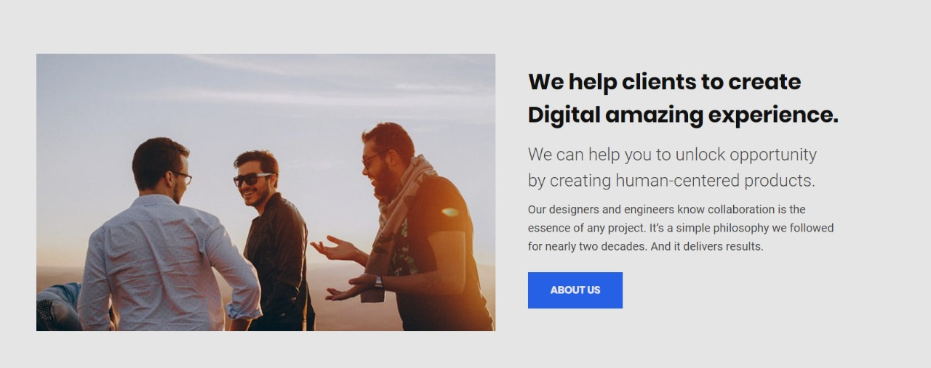

About (page content)

Megapixel Technologies provides their clients with a detailed report that will elaborate on the planning, organizing, implementing, and tracking of their brand’s digital marketing and social media campaigns in order to connect with the right target audiences and achieve their objectives.

Featured work

We Are Cultivating Market Leadership From The Inside Out

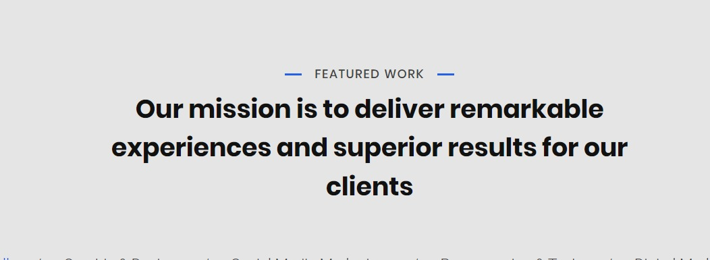

Left Section

Let’s Build And Grow Together & Create The Next Big Thing

Our team is creatively strategy-oriented and focused on providing creative solutions for your creative ideas.

